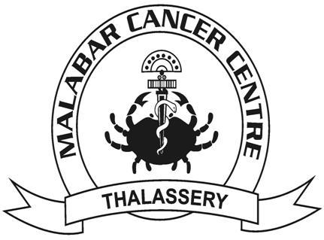

**MALABAR CANCER CENTRE - POST GRADUATE INSTITUTE OF ONCOLOGY SCIENCES AND RESEARCH**

**(MCC-PGIOSR)**

**Fellowship**

**In**

**Oncology Social Work**

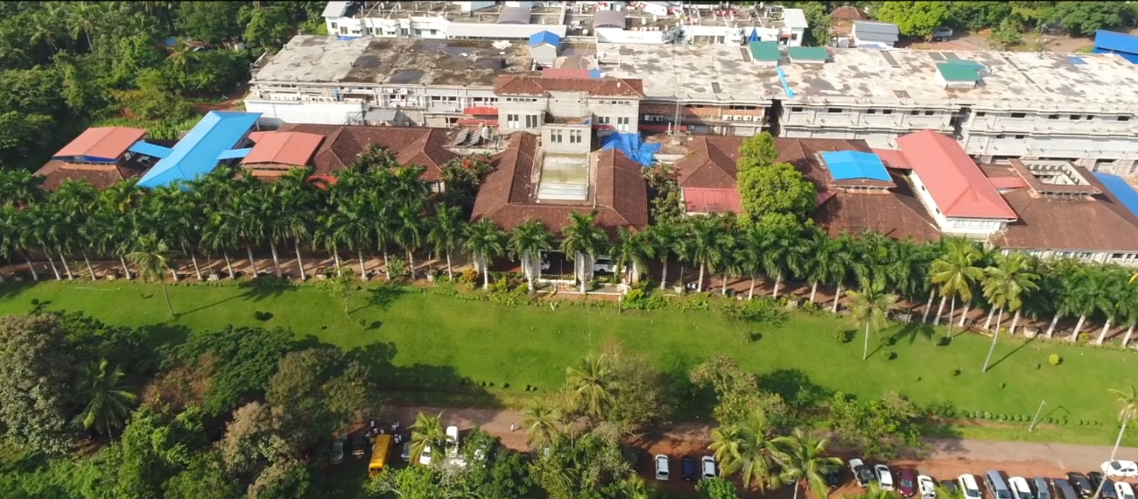

**1.0 Malabar Cancer Centre, Thalassery**

Malabar Cancer Centre - Post Graduate Institute of Oncology Sciences and Research, Thalassery (MCC-PGIOSR) is an autonomous institution under Health and Family Welfare Department, Government of Kerala, started with an aim to establish a comprehensive cancer centre, providing the much-required oncology care to the population of Northern region of Kerala and neighboring parts of Karnataka and Tamil Nadu states. The main objective of the centre is not only to provide comprehensive cancer care but also to develop as a Research and Training Centre of international standards. A society named Malabar Cancer Centre - Post Graduate Institute of Oncology Sciences and Research Society was registered under Societies Registration Act XXI of 1860 with the above aims and clinical work in MCC-PGIOSR started from March 2001 onwards. At present MCC-PGIOSR has more than 200 in-patient bed strength. The control and management of the Society are vested in the Governing Body consisting of 23 members with the Honorable Chief Minister of Kerala as the Chairman. The routine activities and functions of the Centre are supervised by the Executive Committee, with the Secretary, Department of Health and Family Welfare, Government of Kerala being the Chairperson of the Committee. The members in the Governing Body and Executive Committee are functioning by virtue of their official positions.

MCC-PGIOSR provides a full spectrum of oncological care as an autonomous not-for-profit institution funded by the State Government and other sources. Patients are categorized according to their economic status, and accordingly it is expected that 95-97% of patients will be provided free treatment through various financial assistance schemes of the Government. The main modalities of treatment offered by MCC-PGIOSR to patients, presently, include radiotherapy, chemotherapy, onco-surgery and palliative care. The Centre also carries out Community Oncology activities including cancer awareness and early detection programmes. The institute caters to patients from 7 districts of Northern Kerala in addition to the neighbouring states of Tamil Nadu, Karnataka and Mahe (a total population of over 1.5 crores).

**Location: Kodiyeri, Thalassery, Kannur District, Kerala.**

Thalassery (formerly Tellicherry) is a commercial town on the Malabar Coast in Kannur district, in the state of Kerala, India, bordered by the districts of Mahe (Pondicherry), Kozhikode, Wayanad and Kodagu (Karnataka). The town of Thalassery is historically renowned for its 3 “C “ s of ***Cake, Circus and Cricket***. Thalassery is at times referred to as the city of cricket, cakes and circus. It was a British bastion in the pre-independence era with marked contributions of colonial rule.

It is the second largest populated municipality of North Malabar.. The Europeans nicknamed the town "Paris" or in other words "The Paris of Malabar", as it was the sole French military base in Kerala in that era..Thalassery municipality has a population just under 100,000.and an area of 23.98 square kilometres. It is 22 km south of the district headquarters -Kannur city.

Thalassery municipality was formed on 1st November 1866 according to the Madras Act 10 of 1865 of the British Indian Empire, making it the second oldest municipality in the state. At that time the municipality was known as Thalassery Commission, and Thalassery was the capital of North Malabar. G. M. Ballard, the Malabar collector, was the first President of the municipal commission. Later a European barrister, A. F. Lamaral, became the first Chairman of Thalassery municipality. Thalassery grew into a prominent place during European rule, due to its strategic geographic location. Thalassery has played a significant historical, cultural, educational and commercial role in the history of India, especially during the colonial period.

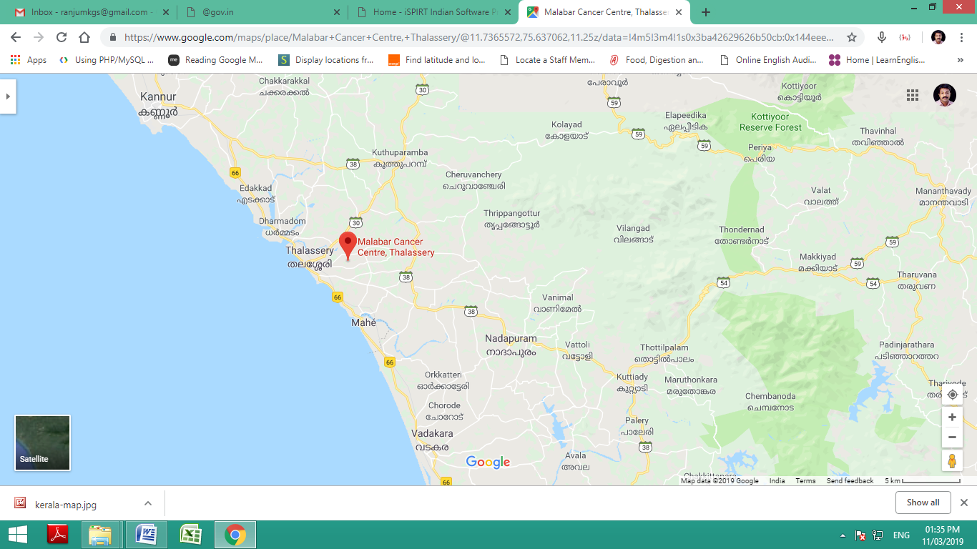

**2.0 Introduction**

**Global Cancer Burden**

Cancer is an umbrella term covering over 40,000 unique disorders characterized by unlimited replicative potential, virtual mitotic immortality and propensity to invade non native tissues. Despite being one of the few curable non communicable diseases, cancer remains a major public health problem worldwide, accounting for over 8 million deaths worldwide. As per Globocan 2018 data, there were 18.1 million new cases of cancer. While cancer has been traditionally viewed as a disease of the affluent world, 65% of the cancer deaths occur in the less developed nations. Cancer is the 4th most common cause of death, accounting for almost 12.5% of all deaths occurring worldwide. Not only does cancer cause suffering in terms of mortality and morbidity, but it also has a significant socio-economic impact. As per the Global Economic Cost of Cancer Report (American Cancer Society), the total economic impact of premature death and disability from cancer worldwide was $895 billion in 2008. This figure, which does not include direct costs of treating cancer, represents 1.5 percent of the world’s GDP. Cancer causes the highest economic loss of all of the 15 leading causes of death worldwide. The economic toll from cancer is nearly 20 percent higher than heart disease, the second leading cause of economic loss ($895 billion and $753 billion, respectively).

## 

## Burden of Cancer in India

As per the estimates provided by Globocan 2018, worldwide the age standardized incidence of all cancers including non melanoma skin cancers, were 218 per 100,000 in males and 182.6 per 100,000 in females. In India it is around 90 per 100,000 population in males and females. In India the five most common cancers are cervical cancer, Breast Cancer, Head Neck Cancers, Lung and Colorectal cancers. This is also unlike the case in the USA where Prostate, Breast, Lung, Colorectal cancers and melanomas are the 5 most common cancers. It should be remembered that this data probably represents a gross under-representation of the true burden as the NCRP data that is the basis for this report has a single rural based cancer registry, where 70% of the Indian population is known to reside. As per Globocan 2018 there are 1.15 million new cancer cases annually. Perhaps more worrisome is the fact that the burden of cancer will nearly double in the next two decades with an estimated 1.7 million new cases and 1.2 billion cancer deaths occurring annually by the year 2035.

As India’s population ages and the deaths attributable to infectious diseases are reduced, the burden of mortality due to non communicable diseases will experience an upsurge. Deaths caused by cancer are projected to increase from 730 000 in 2004 to 1·5 million in 2030, and those attributable to cardiovascular causes from 2·7 million in 2004 to 4·0 million in 2030 as per the Global Burden of disease study.

## 

## Challenges to Cancer Care in India

In a well publicized position paper in Lancet Oncology, Professor Mallathet al, have highlighted several challenges facing our nation in ensuring adequate and equitable cancer care. Despite the substantial socioeconomic progress made over the past 5 decades since Independence, our per capita purchasing power is only 5-10% of that of the Western nations. If we take the example of Trastuzumab, a monoclonal antibody that has proven to have significant benefits in a subgroup of breast cancer patients, the annual cost of treatment for an average Indian female works out to be $20,000. This represents ~ 30% of the cost incurred for the same drug in the USA ($70,000). As can be appreciated in terms of relative purchasing power, the same drug, although retailed for a lesser price, extracts a far more severe economic penalty on Indians. This economic burden is aggravated by the fact that use of such life saving drugs is associated with a net societal economic benefit in terms of quality adjusted life years (QALY) saved. As estimated by Lopes et al, the mean societal cost benefit due to herceptin in Singapore is $4300. Given the central role that a woman plays in the family in India the socio-economic impact of lives lost, due to inability to afford this medication is likely to be higher. This is not only the case for new drugs but also for existing drugs and devices.

India is also experiencing a slower demographic transition in terms of disease burden. While the burden of chronic disease is increasing, a high burden remains for acute infectious diseases and accidents. As a result formulating an effective health policy remains a challenge. India thus requires a health care policy that combats malnutrition while emphasizing prevention of obesity at the same time. Till date the national cancer control program has focussed its efforts on enhancing and upgrading infrastructure at select cancer centres along with emphasizing education as the primary modality for prevention. We lack dedicated screening programmes for most cancers as till date the population prevalence for most cancers is below 5 per 100,000.

As highlighted in the report by Professor Mallath et al, India invests less than 1·5% of its GDP on central government-funded and state-funded health care, out of a total public plus private spend of little more than 4% of GDP. No other comparable nation spends as small a proportion of its national resources on public health care. The situation is further complicated by factors such as poor fiscal governance; sub-optimum (health sector-related) relationships between the federal and state governments; poor public health expertise (compounded by inadequate medical and other health professional education); substantial regional variations; and gross education, caste, and class-related inequalities in income and access to services.

Although Indian society places strong emphasis on familial bonds, there is an absence of a corresponding emphasis on ensuring adequate funding for service requirements in the community. As a result majority of the treatment costs are borne out of pocket resulting in further exacerbation in the disparities in cancer care.

Perhaps the biggest problem faced by the policymakers in India today is the inadequate infrastructure available for training and education for professionals. While 60% of specialist facilities are located in regions to the south and the west of India, 50% of the population lives in the Central and Eastern parts of the country. The regional disparity in cancer care is even more apparent when we consider the imbalance in availability of therapy facilities. In addition to the disparity among regions, there is an imbalance in the availability of services in rural and urban areas. As a result of this disparity patients with cancer often have to travel long distances and stay in suboptimal conditions to access appropriate cancer care which they can afford.

## Challenges to Cancer Research in India

Even more worrisome is the state of cancer research in India. India, which has about 17% of the world population, is involved in only about 1.5% of all clinical trials worldwide. The amount of ongoing research activities can be gauged from the number of clinical trials ongoing in the nation. In this respect a search of the Clinical Trial Registry of India reveals that there are only 331 registered trials in Cancer of which only 141 are actively recruiting participants. Of the 57 clinical trials being conducted in Kerala none are open to recruitment at present. In contrast, a search of the clinical trial registry database of the National Cancer Institute reveals 1518 active clinical trials dealing with various aspects of cancer research. As can be easily appreciated, the number of trials being conducted in India on Cancer at this point of time is less than 10% of what is being conducted in the USA. Perhaps more worrisome is the fact that there is a dearth of investigator initiated research with less than 3% of the registered trials being investigator initiated studies.

Another metric to gauge the research output is the number of publications in peer reviewed journals. In this regard also India is far behind that of the USA. In a bibliometric analysis of publications related to cancer research reported by Patra et al, only 648 publications were identified in Pubmed as originating from India in contrast to the 1,53,341 publications from India. Of the total number of publications, India contributed to only 0.4% of the available publications. The authors found that most of the publications were in low impact factor journals and there was a marked regional disparity with Kerala accounting for only 6.5% of the national research output.

We conducted a search of Pubmed using the same filters and found that 25,047 articles were identified from India. However during the same time period, the total number of publications from the USA was 3, 80,771. In the year 2012, 2122 articles were published from India as compared to 25,364 articles from the USA. Thus over the period of the last decade while some increase in research activities has been observed the total research output of India remains less than 10% of that in the USA.

Hence from the above it can be easily concluded that Cancer research is at a nascent stage in India. Given the dearth of manpower and high patient load at most cancer centres it is not difficult to imagine the reasons behind the lack of research activities. Further impediments in conducting research activities in India include the phenomenon of “brain drain”, lack of appropriate training and infrastructure to conduct research, absence of incentives for conducting research and less funding available for research. Other problems that have been highlighted in a publication by Saini et al and Thatte et al include:

1. Shortage of trained staff well versed in GCP norms.
2. Lack of formal training in bioethics and research methodology
3. Heavy burden of clinical duties
4. Sub-optimal administrative support
5. Absence of oversight of functioning of ethics committees
6. Lack of mechanisms for ensuring quality of ethics review heightens societal concerns about safety of participants.

The current socioeconomic reality of the Indian health care system is that very few patients are able to get access to innovative drugs and treatments. The per capita total spending on health is $132 for India versus $3480 for the United Kingdom (currency assumed to be international dollars as per purchasing power parity). 70.8% of all healthcare expenditure in India is borne by private spending, compared to only 16.1% for the United Kingdom. As a result there is no incentive for international pharmaceutical companies to market the latest products in India. This, coupled with an adverse intellectual property environment, results in the large majority of the innovative drugs reaching the Indian market very late in their development. The need of the hour is to develop a robust mechanism to conduct clinical trials that have relevance to the cancer burden in India in the country itself. In this regard availability and continuous training of manpower assumes paramount importance.

**3.0** **Fellowship in Oncology Social Work**

**This Fellowship programme conducted by MCC-PGIOSR is Institutional Fellowship programme. These programs do not have the recognition of regulatory bodies or universities.**

| **Fellowship Programme in** | **Duration** | **Vacancy** | **Eligibility** |
| --- | --- | --- | --- |
| **Oncology Social Work** | **1 year** | **One** | * The candidate should possess a regular post graduate degree in Master of Social Work (Medical & Psychiatry/ Clinical Social Work) with a minimum of 60% marks. * Candidates should not cross 45 years as on 1st January of current year. |

**Objective of the Programme**

Medical social work is a field that focuses on meeting the various needs of individuals, families and communities navigating challenges in health and wellness. When people are sick, in addition to physical care, they may also need support for the emotional, financial and social needs that can arise. They may feel overwhelmed when dealing with the health care system, need help planning their after-care transition or want counselling support to help them process the changes in their lives.

Oncology social work is a discipline that provides psychosocial services to patients, families and significant others facing the impact of diagnosis of cancer. The scope of oncology social work includes clinical practice, education, advocacy, administration, policy, and research. In India the social work education programmes are limited to the health social work perspective. So there are no specialised programmes in the area of oncology social work available in the country. At the same time there is a significant skill gap in the healthcare system which can be filled by a professional trained in oncology social work only.

Psycho-oncology division of MCC is working with all the Inpatient and Outpatient care departments and divisions in the hospital, including Surgical, Medical, Radiation, Pain & Palliative care, Community Oncology, and Paediatric Oncology along with research and academic aspects of hospital. This ensures that the trainee can be trained thoroughly so that he/she can work as an Oncology Social Work professional.

**Objectives**

1. To develop a regular full time academic program in oncology social work

2. To promote excellence in psychosocial care to oncology patients, families, caregivers and their community through the process of oncology social work.

3. To prepare the fellow to be a specialised oncology social worker to improve the psycho-social well-being and quality of life of cancer patients through various methods of social work

4. To conduct short-term research in Psycho-social oncology along with real clinical experience.

Upon completion of a one-year fellowship, the Oncology social work professionale is expected to possess the following characteristics:

a) Expertise in the multi – professional team working, caring for people with cancer, in a variety of settings, throughout their cancer journey.

b) Ability to manage psycho-social concerns of the cancer patient and their families.

c) Ability to participate in the training of health care professionals and students to improve awareness about the importance of oncology social work.

d) Ability to promote evidence based practice through research and audit.

**Eligibility**

Minimum 60% marks in Regular MSW (Medical and Psychiatry/Clinical Social work )

**Duration of the program**

The duration of the programme is 1 year

**Fellowship Structure**

One year full time clinical training divided into four parts

I. Theoretical Learning

a. Oncology Social work

b. Research Methodology & Biostatistics

II. Clinical & Practical hours

a. Practical Assessments

b. Case work, Group work & Case studies

III. Research Dissertation

a. Viva-voce

IV. Internship ( outside, if required)

a. 2 weeks

b. Community posting (Preventive and social medicine)

**PART I THEORETICAL LEARNING**

PAPER 1: ONCOLOGY SOCIAL WORK

Unit 1: Oncology Social Work-Past, Present and Future

Unit 2: Psycho-social concerns in view of Adaptation to cancer diagnosis and treatment – Prevention, Diagnosis, Treatment, Survivorship, Palliation

Unit 3: Complex Issues Affecting Quality of Life and Quality of Care

Unit 4: Psycho-social interventions in patients, Families and Caregivers

Unit 5: Assessment and Interventions with Children and Adolescent Cancer Patients-The Unique Challenges of Paediatric Oncology social work

Unit 6: Patient- And Family- Centred Care: Social Work Role and Organizational Models for Psychosocial Services

Unit 7: Health Care Advocacy: Legal and Ethical Issues in Oncology

Paper II RESEARCH METHODOLOGY & BIOSTATISTICS

Unit I: Introduction to Research

Unit II: Research Designs, Methods and Tools

Unit III: Statistics

Unit IV: Inferential Statistics

Unit V: Epidemiological Studies

**PART II CLINICAL & PRACTICAL HOURS**

The fellow has to do clinical work including OP and IP consultation with patients and families as individual or group sessions. Every day ward rounds are mandatory. They need to do case discussions and presentations in the division for management and follow up plans. They may need to be involved in Multispecialty Tumor Board (MSB) and grand rounds with other Oncology departments. Different psycho-social assessments used for cancer patients are also part of practical hours. The fellow has to submit a minimum of 10 cases in the whole course from case history, screening and assessment to management. The log has to maintain a log book for the fellowship.

a. Practical Assessments

b. Case study & Case reports

**PART III DISSERTATION & VIVA VOCE**

This provides an opportunity for the fellow to practice research using the knowledge acquired. Fellows will be expected to take up one research study, to be completed within a span of one year. Acquiring extramural funding for these projects will be encouraged and fellows are expected to have a submitted publication prior to completion of the fellowship in the project concerned. In addition to this conference presentations are recommended and encouraged. Fellows will be expected to complete the project prior to getting a completion certificate. Viva voce will be conducted for the fulfilment of the fellowship to get a certificate.

**PART IV INTERNSHIP**

a. 2 weeks (outside, if required)

b. Community posting (Preventive and social medicine)

**Evaluation**

An end of fellowship examination will be conducted to evaluate the candidate in terms of the knowledge gained from the fellowship The examination will be mandatory for passing the fellowship and for grant of the fellowship completion certificate along with completed project work mentioned above.

Fellow has to attend two theory examinations – Oncology Social Work and Research methodology and Biostatistics. Each theory exam will carry 80 marks for written theory paper and 20 marks for internal/practical examination. The research dissertation, viva voce and clinical viva will be conducted by an external faculty. The maximum mark for the same is 100. The pass percentage in all three will be 50%.

**4.0 Submission of application**

**Online Application:**

The applications should be submitted ONLINE through our website **www.mcc.kerala.gov.in.**

**Application Fee:**

Application fee is **Rs.1,500/-** (Rupees One Thousand Five hundred only). The application fee shall pay online through the payment gateway system provided in the online application

**Selection process:**

The selection will be based on an online screening test and/or personal interview.

**5.0 Fees and Stipends**

Fellowship fees of Rs.15,000/- per annum with alumni fee of Rs. 750/- will be levied and Rs.5,000/- will be the refundable caution deposit (Total 20,750/- ). Stipend of Rs.12,000/- per month will be given for non sponsored candidates. For sponsored candidates and candidates from other countries the institution may decide on the fee structure as appropriate

**6.0 Faculties**

| **Surgical oncology** | Dr.Satheesan Balasubramanian, M.S. M.Ch. (Surgical oncology) Director & Professor, HoD in Surgical oncology. |
| --- | --- |
| Dr.Nizamuddin.M.P (MS, MCh.), Additional Professor and HoD, Dept.of Surgical Oncology |
| Dr AdarshD . MS (OBG), Assistant Professor in Gyn Oncology  Dr Sandeep Vijay MS (ENT), Assistant Professor  Dr Anoop.A MS (ENT), Assistant Professor  Dr Ashitha MS (OBG), Assistant Professor  Dr.Bony A Joseph, (MS, MCh.), Assistant Professor  Dr. Prasanth P, DrNB, Assistant Professor  Dr. Raveena R Nair, Assistant Professor |
| **Clinical hematology and medical oncology** | Dr.Chandran K. Nair, M.D.,DNB(Int. Medicine), D.M. (Clinical Hematology), Fellowship in Bone Marrow/Peripheral blood Stem cell transplantation(Vancouver, Canada)  Professor and HOD |
| Dr.Praveen Shenoy (MD, DM), Associate Professor |
| Dr.Jithin T K (MD, DM), Assistant Professor |
| Dr.K G Gopakumar (MD, DM),Assistant Professor |
| Dr. Nandini Devi, (MD, DM), Assistant Professor |
| Dr. Abhilash Menon, (MD, DM), Assistant Professor |
| Dr. Arun Krishnan M P, (MD, DM), Assistant Professor |
| **Clinical laboratory services and translational research** | Dr.Sangeetha K Nayanar MD, DNB (Pathology)  Professor and HOD |
| Dr.Parthiban R, PhD Professor, Microbiology |
| Dr.SitharaAravind MD (Pathology), Additional Professor |
| Dr Mohandoss M MD (Transfusion Medicine), Additional Professor |
| Dr Aswathy Krishnan M MD,DNB (Pathology), Associate Professor |
| Dr Kandathil Philip Joseph MD,DNB (Pathology), PDCC Assistant Professor |
| Dr Anand Narayanan MD (Pathology), Assistant Professor |
| Dr.Vivek Nair, MD(Pathology), Fellowship in Oncopathology Assistant Professor |
| Dr.Deepak Roshan PhD , Associate Professor, Cytogenetics |
| Dr.Vipin Gopinath PhD, Associate Professor, Molecular Oncology |
| Dr.Sindhu ER PhD, Assistant Professor, Biochemistry |
| Dr Sarath KE MD, Assisstant Professor, Microbiology |
| **Radiation oncology** | Dr.Geetha M. MD (Radiotherapy),Professor and HOD  Dr Vinin N V MD (Radiotherapy), Additional Professor  Dr Joneetha Jones MD,DNB(Radiotherapy), Associate Professor  Dr Greeshma K E DMRT,DNB (Radiotherapy), Associate Professor  Dr Nabeel Yahiya MD (Radiotherapy), Assistant Professor  Dr Arun.P.Narendran MD,DNB(Radiotherapy), Assistant Professor  Dr Akhil.P.Suresh MD (Radiotherapy), Assistant Professor  Dr. Megha Prem, MD (Radiotherapy), Assistant Professor |
| **imageology** | Dr Nrithi P , MD ( Radiodiagnosis) , Assistant Professor  Dr. Suryakala, MD ( Radiodiagnosis) , Assistant Professor  Dr. Ashish Pavanan, MD ( Radiodiagnosis) , Assistant Professor |
| PULMONOLOGY | Dr Anu Mariyam , MD (Pulmonology), Assistant Professor |
| **palliative medicine** | Dr Biji M S, Assistant Professor |
| **community oncology** | Dr Neethu,MBBS,MPH, Lecturer  Dr Phinse Philip, BDS,MPH,PhD,Lecturer |
| **cancer registry &** EPIDEMIOLOGY | Dr SainaSunilkumar, MBBS,MPH,Lecturer  Mr Ratheesan,MSc,MBA,Lecturer in Biostatistics  Dr. Bindu, MSc,PhD, Lecturer in Biostatistics |
| CLINICAL RESEARCH & BIOSTATISTICS | Mrs Maya Padmanabhan,MSc,Mphil, Lecturer in Biostatistics  Mr Riyas,MSc,Lecturer in Biostatistics |
| PSYCHO-ONCOLOGY | Mrs. Jisha Abraham,MSc,Mphil, Lecturer in Psycho-oncology |

**7.0 rules and Regulations**

1. The course is full time. Candidates are expected to perform all types of clinical, research and academic assignments as prescribed by the Academic Council of Malabar Cancer Centre - Post Graduate Institute of Oncology Sciences and Research.
2. It is a resident program of post-graduate training
3. Candidate is expected to wear identity card provided by MCC-PGIOSR
4. **Dress code:** Lady candidates are expected to put up the hair during working hours. She is permitted to wear any decent dress preferably, Sari and churidhar. Gentleman candidates should wear formal shoes. White apron is compulsory during working hours
5. **Attendance:** The candidate should mark the attendance in Biometric punching machine and also sign in the register kept in the department.
6. Completion of project work is compulsory for fellowship certification.
7. **Leaves:** Candidates will be eligible for 12 days leave during the programme. Not more than 5 days of leave will be granted together. Candidates who avail for more than 12 days of leave will have extension for those additional days of leave. Holiday leave/ holiday duty off will be given as per discretion of the Head of Department.
8. **Accommodation:** Accommodation is the responsibility of the candidate. For lady candidates, if available and formally requested in the Request form, shared room accommodation may be provided in the Nurses hostel. This is not guaranteed and it is not a right of the candidate. If accommodation is provided a nominal rent will be deducted from the stipend. A caution deposit of Rs. 1,000/- should be paid. This is refundable when the candidate vacates the hostel. Gentleman candidate is expected to find an accommodation themselves
9. Candidates should follow the rules and regulations of MCC-PGIOSR.

**8.0 Contacts**

**For any clarifications and queries, please feel free to contact;**

* + Dr.Sangeetha K Nayanar, Professor & HOD, Department of Clinical Laboratory Services and Translational Research,

E-mail: [sgeetanayanar@yahoo.com](mailto:sgeetanayanar@yahoo.com), Phone: 0490 2399 219

* + Dr.Chandran K Nair, Professor & HOD, Department of clinical Hematology and Medical Oncology

E-mail: [cknair09@gmail.com](mailto:cknair09@gmail.com),Phone:0490 2399 245

* + Dr.Satheesan B, Professor & HOD, Department of Surgical Oncology,

E-mail: [directormcctly@gmail.com](mailto:directormcctly@gmail.com), Phone: 04902399212

* Dr.Geetha M, Professor & HoD, Department of Radiation Oncology

Email: [geethasatheeshan@gmail.com](mailto:geethasatheeshan@gmail.com), Phone: 04902399232

* Dr.Nizam M Pareekutty, Additional Professor, Department of Surgical Oncology

E-mail:[drnizamudheen@gmail.com](mailto:drnizamudheen@gmail.com),, Phone: 04902399214

* + Dr Nrithi P , Department of Radiation Oncology

Email: [nrithisp@gmail.com](mailto:nrithisp@gmail.com), Phone:0490 2399234, 2399566

* + Dr.Mohandoss M, Additional Professor, Division of Transfusion Medicine

E-mail: [mohandossmurugesan@gmail.com](mailto:mohandossmurugesan@gmail.com),, Phone: 0490 2399 227

* Mrs.Maya Padmanabhan, Division Incharge,, Division of Clinical Research & Biostatistics

Email:[mayapnambiar@gmail.com](mailto:mayapnambiar@gmail.com) ,Phone 04902399249

* Mrs.Jisha Abraham,Division Incharge, Division of Psycho Oncology

Email:[jishasarah@gmail.com](mailto:jishasarah@gmail.com), Phone:04902399268

Any technical queries regarding online applications please contact System Manager, Email: [sm@mcc.kerala.gov.in](mailto:sm@mcc.kerala.gov.in) with application Number (Phone: 0490-2399400, 2359881)

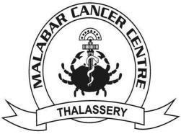

MALABAR CANCER CENTRE - POST GRADUATE INSTITUTE OF ONCOLOGY SCIENCES AND RESEARCH

(An Autonomous Institution under Govt. of Kerala)

Moozhikkara (P.O), Kannur District, Kerala, India-670103.

Phone: 0490 2355881, Fax: 0490 2355880

E-mail: mcctly@gmail.com, Website: www.mcc.kerala.gov.in